Application for Resource for Faculty Funded Time for Research (FFT)

The application is divided into three sections:
I. General details, this page.
II. Presentation of specific information, page 2 of the form and onwards.
III. Presentation of the research program.
Incomplete applications will not be processed.
Send your application incl. research program as one attached PDF document by e-mail to the Registrar medel@diarie.umu.se no later than May 17, 2022.
As subject of the e-mail state: Dnr FS 2.1.6-184-22

Part I

Applicant name:
Department:
Position (employed in (%) as):
Docent (date of appointment):
Current tasks within the post (state the extent (in %) for the tasks included in your employment, e.g., research xx%, teaching yy%, administration zz%)

Research area:
The application concerns the time period: (as: From 2023 – Until 20xx).
The application concerns FFT to the extent: (% of full-time work)
FFT already granted for 2023 and onward:
Short summary of the research:

Part II
Publications
Bibliometric information should be taken from the database Google scholar, but the applicant can also give information from other sources in parallel.
Use Google Scholar as source for this table. | Year of first original scientific article: | Total number of peer reviewed articles | Total number of peer reviewed conference papers
Total number of citations: | Average number of citations per publication: | Total number of citations, from 2015: | H-index:
Total number of publications as first author from 2015: | Total number of publications as last author1 from 2015: | Total number of publications as corresponding author1 from 2015: | Total number of publications on the  Norwegian register  at level 2 from 2015:

Original scientific articles in journals with peer review system, including review articles. Present published work, from 2015, numbered, in reverse chronological order (i.e., 2022 on top). Note that the reported details may be compared against data in Opus Diva. For each year, state the published works in terms of list of authors, title, journal, etc. with your name in bold. State also the number of citations, the journal’s “impact factor” according to ISI. If possible, give also clickable search links to your work.
To assess the degree of external activity, i.e. to assess the extent of interdisciplinary, national and international collaborations (which is done by taking into account the proportion of peer-reviewed published work that have co-authors from another department, from another national or international university, and from non-academic actors such as research institutes and companies), as well as the level of the applicant’s, relevant information will be retrieved by the use of centrally purchased bibliometric tools.
Different disciplines have different norms and traditions in terms of the order of authors and “impact factors”. For example, within some disciplines alphabetical order by author is used. The assessment committee takes this into account in its assessment of applications.
Peer reviewed articles.
Author (your name in bold), Title, Journal, Vol., Pages, Year Other Number of citations Journal impact factor (ISI) Search string, level in the Norwegian register.

Books or chapters in books.

Peer-reviewed conference papers.

Other publications (manuscript submitted for publication, software, other conference papers, reports, patents, etc.).

Supervision of Doctoral students
Doctoral students for whom the applicant is the principal supervisor or assistant supervisor. State according to the registered information in LADOK at the time of the application:

Doctoral students admitted for studies towards a doctoral degree. State name and time period.
As principal supervisor:

As assistant supervisor:

Doctoral students admitted for studies towards a licentiate degree. State name and time period.
As principal supervisor:

As assistant supervisor:

Doctoral students - examinations
Completed doctoral degrees, from 2015, in which the applicant has been the principal supervisor or assistant supervisor, according to information registered in LADOK. If the same person has completed both a degree of licentiate and doctor, indicate only the degree of doctor.

Degree of Doctor. State name and year for thesis defense.
As principal supervisor:

As assistant supervisor:

Degree of Licentiate. State name and year for licentiate seminar.
As principal supervisor:

As assistant supervisor:

Supervision of Postdoctoral researchers
Postdoctoral researchers for whom the applicant is or has been in charge, from 2018. State name, time period, and financial body.

Paid time for your own research/research supervision (please tick relevant boxes)
percent of full working time | 2017 | 2018 | 2019 | 2020 | 2021
0-20 %
21-40 %
41-60 %
61-80 %
81-100 %

Personal research funding from external research funding bodies
State contributors, time period for received and guaranteed external funding and the size of the grant (in kSEK) annually from 2018 and onwards. For applications with several applicants, state your own share of the grant.  Funding body – Time period - Project title – Amount (own share)  As principal applicant: | 2018 | 2019 | 2020 | 2021 | 2022 | 2023 | 2024 | Total
As co-applicant:

Applications for external research funding submitted during the period 2019 to present that have been rejected or for which no decision has been taken yet .
Include both rejected and pending applications.
State contributor, time period and total amount applied for (in kSEK/year).
In applications with multiple applicants, state your own share of the budget.
State whether the application was rejected, or if a decision is yet to be obtained.
As principal applicant:

As co-applicant:

Teaching work
First- & Second-cycle (bachelor and master level) education

Development of new courses/course development.

Third-cycle education (courses on PhD level).

Miscellaneous
Commissions of trust – External (Assignments as editor or expert, conference participation, external research assignments, opinions received from research committees, awards, etc.)

Commissions of trust – Internal (work within the university that the applicant has been assigned/taken on; member of the faculty board or faculty committees, other research and/or teaching administration of importance to the faculty.)

Management positions (Head of department/assistant head of department. Other management positions.)

Equality work
Present participation in equality work.

Interaction with the surrounding community

Additional information of relevance for the application/Particular conditions (e.g. extended periods of sick leave, parental leave or planned leave of absence.)

For application of additional FFT (swe. “upptoppning”) - Justification (account of significant strengthening of the applicant’s qualifications since the last FFT allocation.)

Appraisal of to which degree your research relates to the UN’s 17 sustainable development goals
To assess to which extent the research at the Faculty of Science and Technology relates to the UN’s 17 sustainable development goals (SDGs), we encourage you to participate in the survey below. The extent of addressing these goals does not affect the assessment of your FFT application.
Indicate in the table below to what extent (1 - 6) your research relates to each global sustainability goal (1: not at all; 2: marginally; 3: to a certain extent; 4: to a not insignificant extent; 5: to a significant extent; 6: to a considerable extent).
The 17 sustainable development goals (SDGs) are:
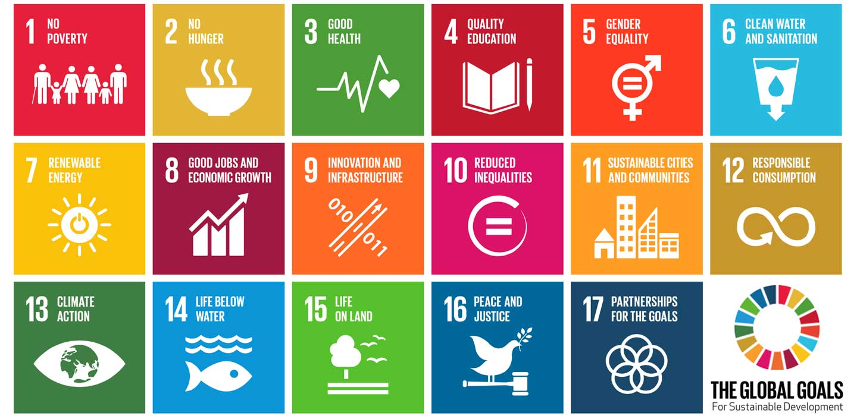
Sustainable development goal (SDG) | Extent  (1-6) |  | Sustainable development goal (SDs) | Extent  (1-6)
1. No Poverty |  |  | 10. Reduced Inequality
2. No Hunger |  |  | 11. Sustainable Cities and Communities
3. Good Health and Well-being |  |  | 12. Responsible Consumption and Production
4. Quality Education |  |  | 13. Climate Action
5. Gender Equality |  |  | 14. Life Below Water
6. Clean Water and Sanitation |  |  | 15. Life on Land
7. Affordable and Clean Energy |  |  | 16. Peace and Justice Strong Institutions
8. Decent Work and Economic Growth |  |  | 17. Partnerships to achieve the Goal
9. Industry, Innovation and Infrastructure
Definitions of UN’s 17 sustainable development goals can be found here: https://www.un.org/sustainabledevelopment/sustainable-development-goals/
Part III
Research programme
At most three A4 pages, either Georgia font size 10 or Times New Roman font size 12.
State the project title, introduction, objectives, hypotheses, methods, and expected results.

Fill in this only if it is of relevance for your research subject.

