SOUTH AFRICA – SWEDEN UNIVERSITY FORUM
Planning meeting, Pretoria – October 2-3 2017

Position paper for the first research seminar in Pretoria, XXX 2018

Topic/Challenge Headline
Climate change, natural resources and sustainability

Description of challenge (The challenge should be relevant for both countries, approachable from an interdisciplinary perspective, relevant to industry, NGOs and/or surrounding society, linked to one or several of the 17 SDGs)
Climate change (goal 13) is the framework within which natural resources, living and non-living (goal 14 and 15), and sustainability* are considered. Climate change has direct causal and effectual influences on food security (goal 2), water security (goal 6) and energy/resource security (goal 7). Climate change affects food production, food production affects climate. Climate change affects water (includes fresh water and marine systems) and changes in the aquatic cycles have an impact on climate. Energy (in all its consumption) impacts climate, and as climate changes, it impacts availability of energy sources. Conducting research in this space requires intra/inter/cross/trans and enmeshed disciplinarity. The research is conducted with a view of advancing towards a circular economy based on responsible consumption and production (goal 12, ”cradle to cradle”).

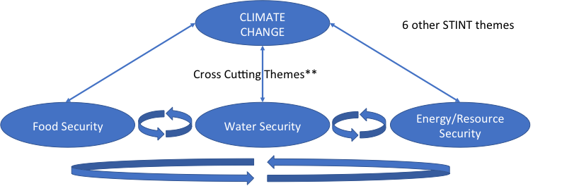

Drivers: lack of, or unsustainable use of resources (food, water, energy) is a major challenge for a growing population
*Sustainability: environmental, social and economical sustainablility
**Cross-cutting themes f.e. circular economy, ecosystem management and biodiversity, innovation, transdisciplinarity, risk assessment, employability, governance

Key research questions
- What is the impact of climate change on resources needed for survival?
- How does food, water and enegy use impact on climate?
- What are the elements (factors) with regards to food – water – energy security that impact climate change?
- How does the north to south component impact food – water – energy security (separately or jointly)?
- How can we develop circular economy models applicable on a local scale?
- How does climate change impact eco terrestrial and marine biodiversity?
- What is the ecological impact of food – water – energy use?
- What are the enabling technologies and innovations to address the challenges in a circular economy?
- What is the social impact of climate change?

Research areas/keywords
Climate change, transdisciplinarity, employability, water (fresh and marine), renewable energy, biodiversity, conservation, food security (agri and aqua), circular economy, ecosystem management, innovation (as in developing innovative ideas and solutions), marine litter, waste management, risk assessments
Researchers in Academic Advisory Committee (AAC) (including Chair) (2 SE+ 2 SA)

1. (chair) name/university. University of Gothenburg is suggested to take the chair.
2.
3.
4.

Dates for next meeting AAC:

DAY 2

Description of possible surrounding activities across South Africa (for instance, innovation & industry seminar, outreach activities, guest lectures, capacity development of young researchers, academic workshops etc.)

- UWC and UCP: “Summer school” on food over a few days inviting speakers on the food security theme. Learning, culture, technologies including visits to different local food producers– a cooperation between UWC and UCP.
- NMU: One-day workshop focusing on water, f.e. marine litter working together with Wits and Durban.
- Wits: Renewable energy (fuel cells and batteries) a workshop with experts and emergin scientists, stakeholders: industry, Dep of science and technology, CSIR,
- DUT: They will have a workshop in March (funded by STINT). Focus hydrological and hydrodynamic modeling linked to microbiological and antibiotic resistance. Is it possible to co-fund this workshop and see this as a joint activity? DUT is willing to join other universities as co-organizer of side-events and also to give seminars in other events.
- UWC: Generic scills workshop on how to write grant, proposal writing and publication writing. Use some old and some new material already available and develop a tool. Maybe an activity for the interactive platform.

Please describe any ideas for how the interactive platform can be utilized in the surrounding activities:
- A web-based SDG Impact assessment which is a tool for screening of the projects against the impact (positive – no impact – negative) on the 17 SDG:s. This tool should be used as a learning about the SDGs process. The tool aready exists and has been used successfully ( see Ocean solutions report) and can be adapted to the needs of the project. Papers (applications) should be oriented towards presenting a solution(s) to one or several SDG:s.
- Presentations from the workshops and seminars can be filmed and put on the web
- Joint publications database
- CV-based information about participants
- Web-based streamed seminars happening outside the research and innovation weeks
- The annual report should be done as a “brag-book” for external use to market and attract funding. Showcasing is important.
- Apply to NRF for an international conference in SA in 2019 to showcase the results from this project.
- Put the abstracts online before the conferences so participants can find potential collaborators prior to the conference.

